FLH - SQL QUERIES

1. Creating the database

Create database flh;

1. Using the database

Use flh;

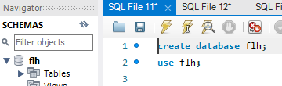

**Q1. What are the neighborhoods that FLH needs to target?**

SELECT neighbourhood_group, neighbourhood, COUNT(*) AS count

FROM df_flh

GROUP BY neighbourhood_group, neighbourhood

ORDER BY count DESC

LIMIT 10;

OUTPUT:

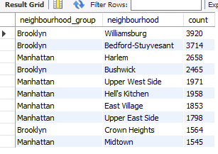

**Q2. What are the pricing ranges preferred by FLH customers?**

-- Define price ranges

SET @bins = '0, 50, 100, 150, 200, 300, 500, 10000';

SET @labels = '0-50, 51-100, 101-150, 151-200, 201-300, 301-500, 501+';

-- Create a new column for price ranges

SELECT

price_range,

COUNT(*) AS count

FROM (

SELECT

CASE

WHEN price >= 0 AND price < 50 THEN '0-50'

WHEN price >= 50 AND price < 100 THEN '51-100'

WHEN price >= 100 AND price < 150 THEN '101-150'

WHEN price >= 150 AND price < 200 THEN '151-200'

WHEN price >= 200 AND price < 300 THEN '201-300'

WHEN price >= 300 AND price < 500 THEN '301-500'

WHEN price >= 500 THEN '501+'

END AS price_range

FROM df_flh

) AS price_ranges

GROUP BY price_range

ORDER BY FIELD(price_range, '0-50', '51-100', '101-150', '151-200', '201-300', '301-500', '501+');

OUTPUT:

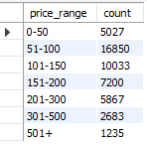

**Q3. What are the types of properties that are most successful and least successful for FLH?**

SELECT

room_type,

COUNT(number_of_reviews) AS count_of_number_of_reviews

FROM df_flh

GROUP BY room_type

ORDER BY room_type;

OUTPUT:

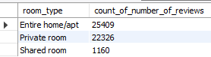

**Q4. What are customers looking for most in their stays with FLH?**

SELECT neighbourhood_group AS Neighbourhood_group,

room_type AS Room_Type,

SUM(number_of_reviews) AS `sum of Reviews`

FROM df_flh

GROUP BY neighbourhood_group, room_type

ORDER BY neighbourhood_group;

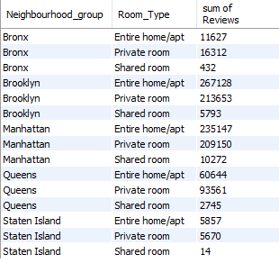

**Q5. What attributes do the hosts have that FLH should target to add to their service to increase revenue?**

SELECT

host_id,

host_name,

COUNT(calculated_host_listings_count) AS total_listings_count,

SUM(number_of_reviews) AS total_number_of_reviews

FROM df_flh

GROUP BY host_id, host_name

ORDER BY total_listings_count DESC, total_number_of_reviews DESC

LIMIT 10;

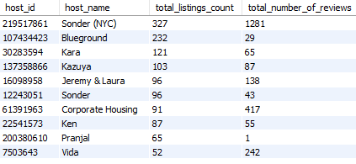

**Q6. How to get unpopular properties more traction?**

SELECT

availability_365,

COUNT(*) AS count

FROM df_flh

WHERE number_of_reviews < 10

GROUP BY availability_365

ORDER BY availability_365

LIMIT 10;

